Armchairs for free

As many readers will know, ICARE has sadly had to close its Day Centre at Green Street Green.
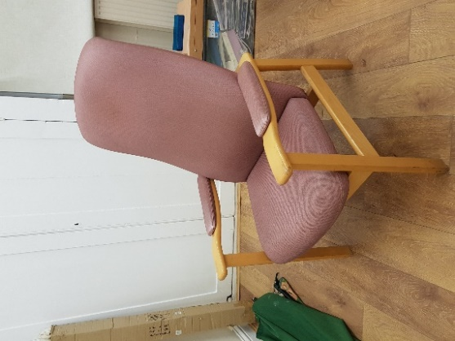
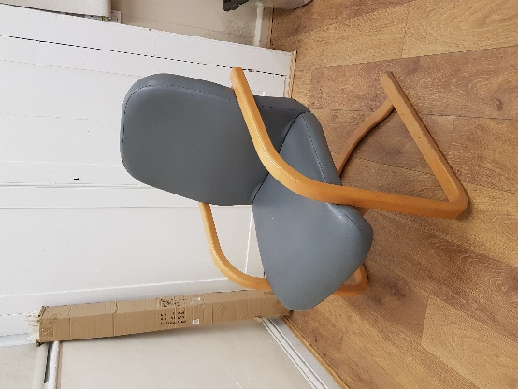
We have several armchairs in good condition for which we would like to find homes. There are two styles covered in pink or grey wipe-clean fabric and all have fire safety labels,
Would you like one of these? There is no cost but you will have to arrange collection, as we are not able deliver ourselves.
If you are interested in one of the armchairs, please get in touch with the ICARE Trustees via admin@icarecentre.org.uk.

